Step-by-Step Guide to Install ora2pg on Windows



Prepared by

**Paula Berenguel**

DM Jumpstart Engineering Architect

[pabereng@microsoft.com](mailto:pabereng@microsoft.com)

Dec-2018

This document is meant to be used as a Quick Installation Guide for enabling migration of schema & data from Oracle to Azure Database for PostgreSQL using ora2pg tool. Complete details on the tool can be found at http://ora2pg.darold.net/documentation.html

Pre-Requisites

The following software must be installed in the Windows machine prior to installing ora2pg:

* Perl 5.10 or more
* Oracle Instant Client or Full Oracle installation
* [optional] Visual C++ or Visual Studio Express
* DBD::Oracle Perl Module
* ora2pg

It is recommended that you use the order above to proceed with the installation.

Note that the version of Windows used for this exercise is a Windows Server 2016

Installing Perl 5.10 or more

1. go to <http://strawberryperl.com/> and download the latest version of Perl – as of now 5.28 is the latest version
2. Double click on strawberry-perl-5.28.0.1-64bit

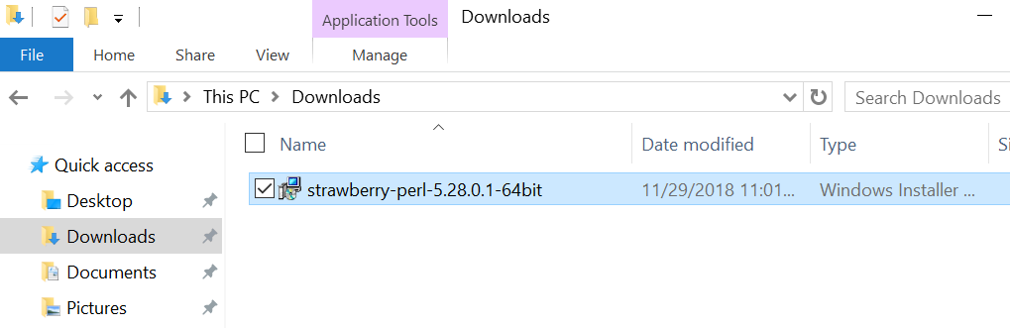

1. Run the wizard until the end of installation:

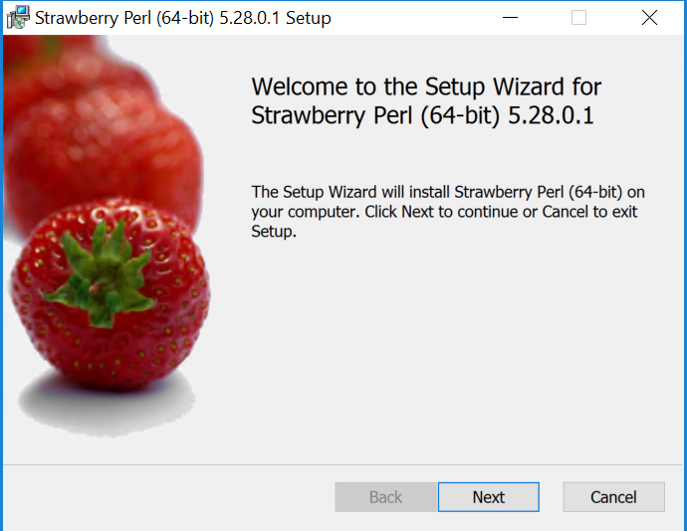

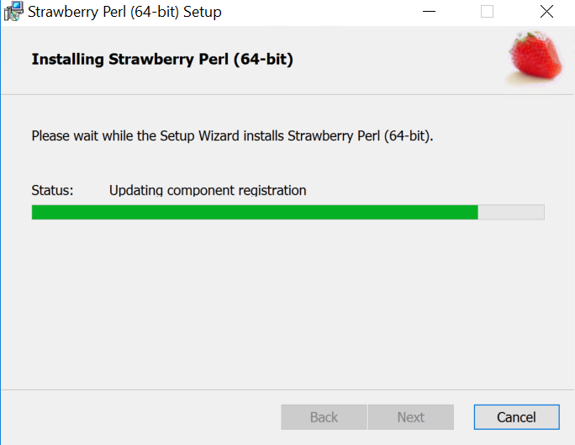

1. Verify that Perl was installed successfully:

cmd> perl --version

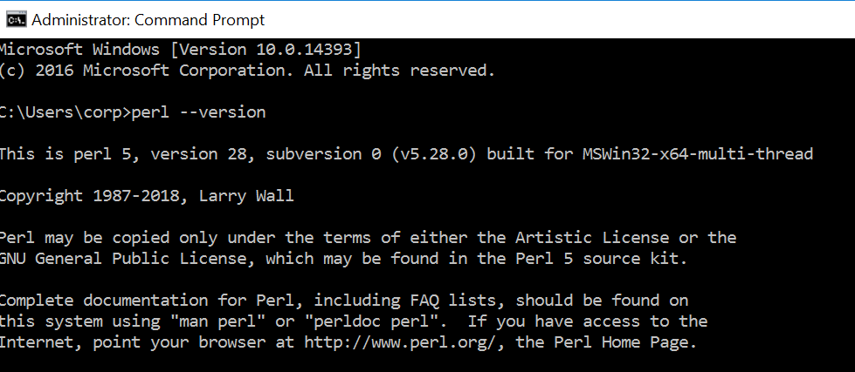

Installing Oracle Instant Client or Full Oracle Installation

1. Go to <https://www.oracle.com/technetwork/database/enterprise-edition/downloads/index.html> and download either the oracle client or a full Oracle Installation

For this exercise a full Oracle Database software will be installed

1. Extract the Oracle file *winx64_12201_database.zip* to any location

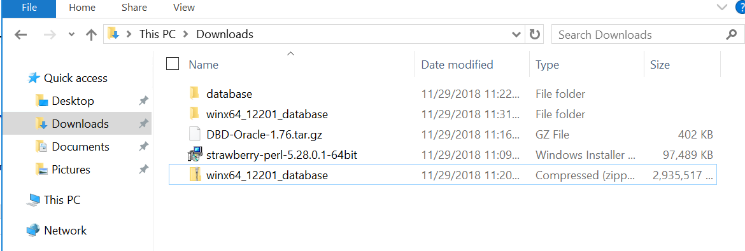

1. Navigate to the extracted folder “winx64_12201_database” -> database and double click on setup to install the Oracle database

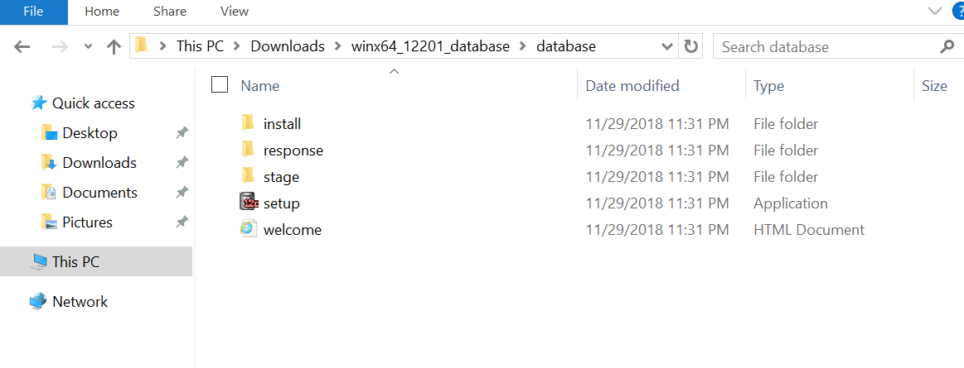

1. Run the wizard until it finishes and wait for the Oracle product to be installed

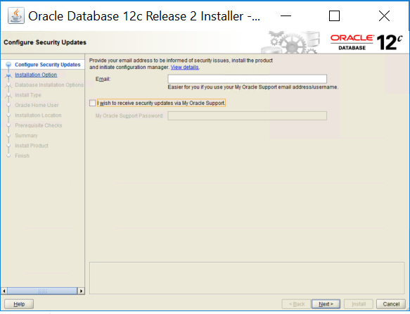

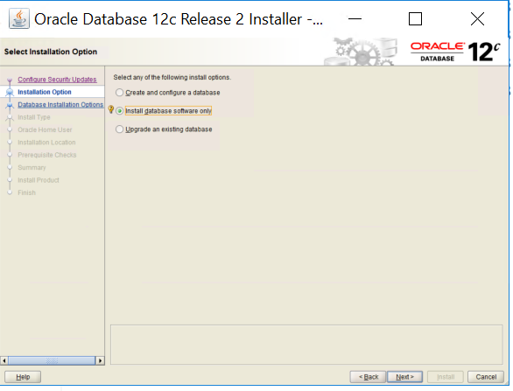

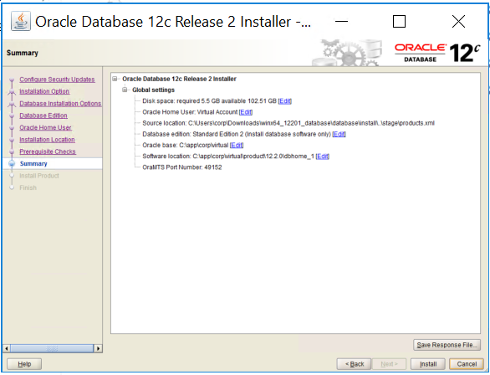

Installing DBD::Oracle Perl Module

1. Go to <https://metacpan.org/pod/DBD::Oracle> and click on “Download”

The file DBD-Oracle-1.76.tar.gz will be downloaded

1. Extract the file to the C:\ drive – use winzip or winrar or any other “untar” tool available in the machine
2. Open a Command Prompt (cmd) and navigate to the C:\DBD-Oracle-1.76

cd c:\DBD-Oracle-1.76\DBD-Oracle-1.76\

1. Set your ORACLE_HOME to the Instant Client directory

set ORACLE_HOME=C:\app\corp\virtual\product\12.2.0\dbhome_1

1. Set your NLS parameter as below

set NLS_LANG=.WE8ISO8859P15

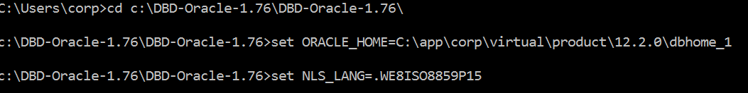

1. Once the NLS and ORACLE_HOME parameters are set, run the following:

perl Makefile.PL

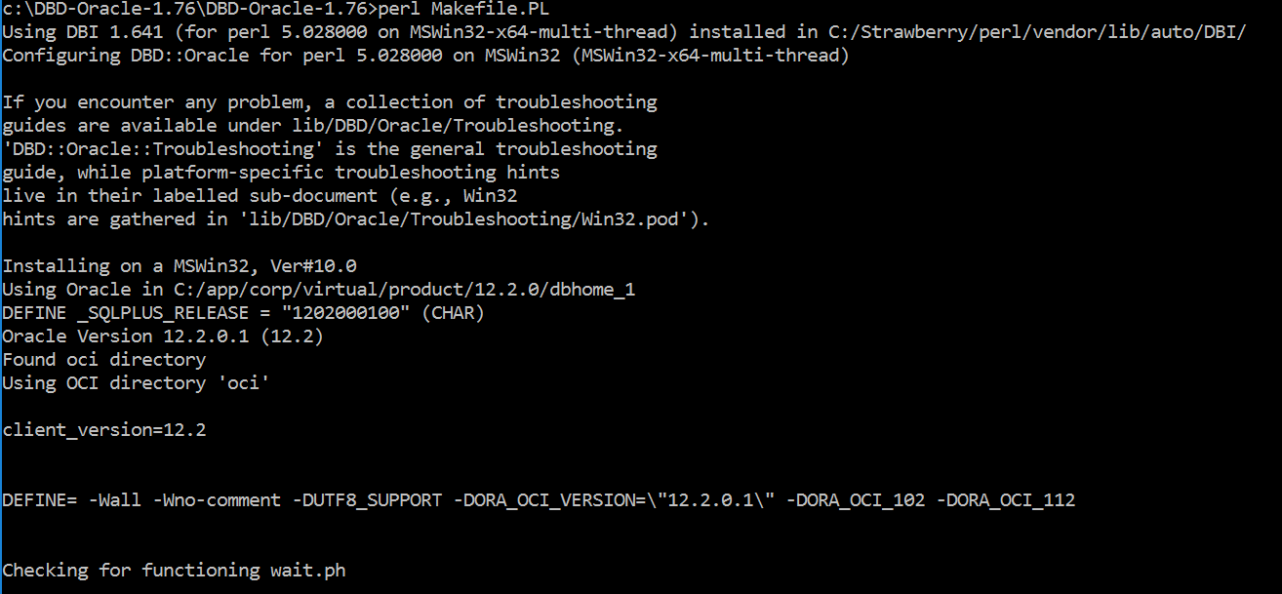

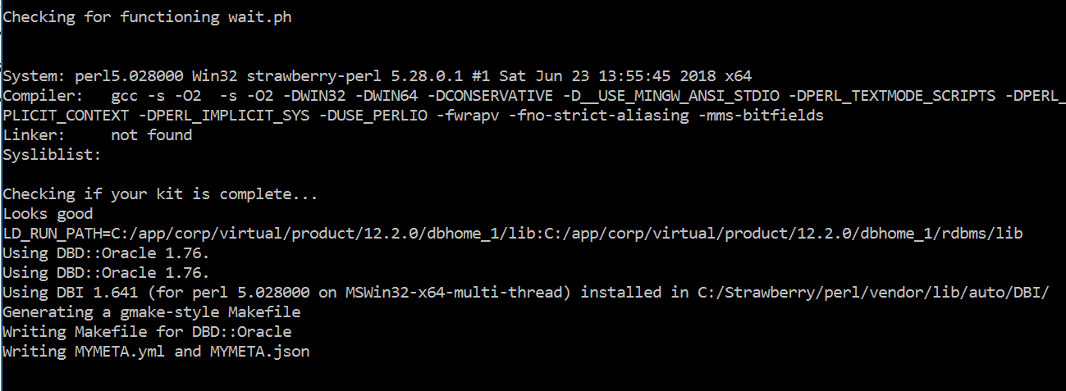

[optional]

The next step is to run nmake install. Visual Studio Express or Visual C++ Express is needed on the Windows Server, so nmake is a command enabled in the windows server.

<https://social.technet.microsoft.com/wiki/contents/articles/50941.visual-studio-express-2017-offline-installer-win7-install-instructions.aspx?Redirected=true>

Complete the installation of Visual Studio Express in order to enable nmake.

[\optional]

"C:\Program Files (x86)\Microsoft Visual Studio\2017\WDExpress\VC\Tools\MSVC\14.16.27023\bin\Hostx86\x86\nmake.exe" install

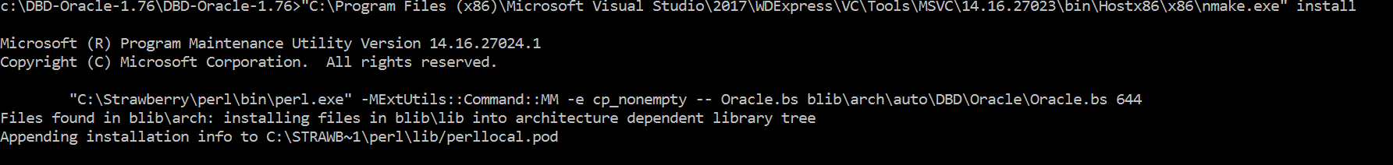

At this point you are all set.

Installing ora2pg

1. Go to <https://sourceforge.net/projects/ora2pg/> to download ora2pg
2. Go to ora2pg installation folder

cd ora2pg-19.1

1. Type perl Makefile.PL

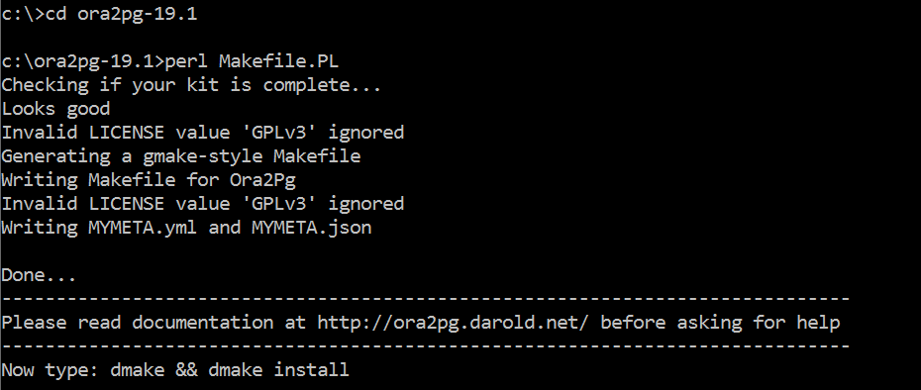

1. Set the environment variables: ORACLE_HOME and LD_LIBRARY_PATH

ORACLE_HOME=<Oracle client software location>

LD_LIBRARY_PATH=<Oracle client software location>/lib

In this install:

set ORACLE_HOME=C:\app\corp\virtual\product\12.2.0\dbhome_1

set LD_LIBRARY_PATH=C:\app\corp\virtual\product\12.2.0\dbhome_1\lib



1. gmake && gmake install

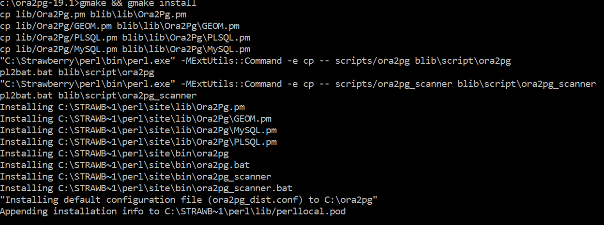

ora2pg is set.

Testing ora2pg installation

Type ora2pg –version as following:



References

<http://ora2pg.darold.net/documentation.html>

<http://strawberryperl.com/>

<https://www.oracle.com/technetwork/database/enterprise-edition/downloads/index.html>

<https://metacpan.org/pod/DBD::Oracle>

<https://blog.pythian.com/dbdoracle-and-windows-64bit/>